**DB Lab 08**

**Name:** Hafsa Salman

**Roll no.** 22K-5161

**Task no. 01**

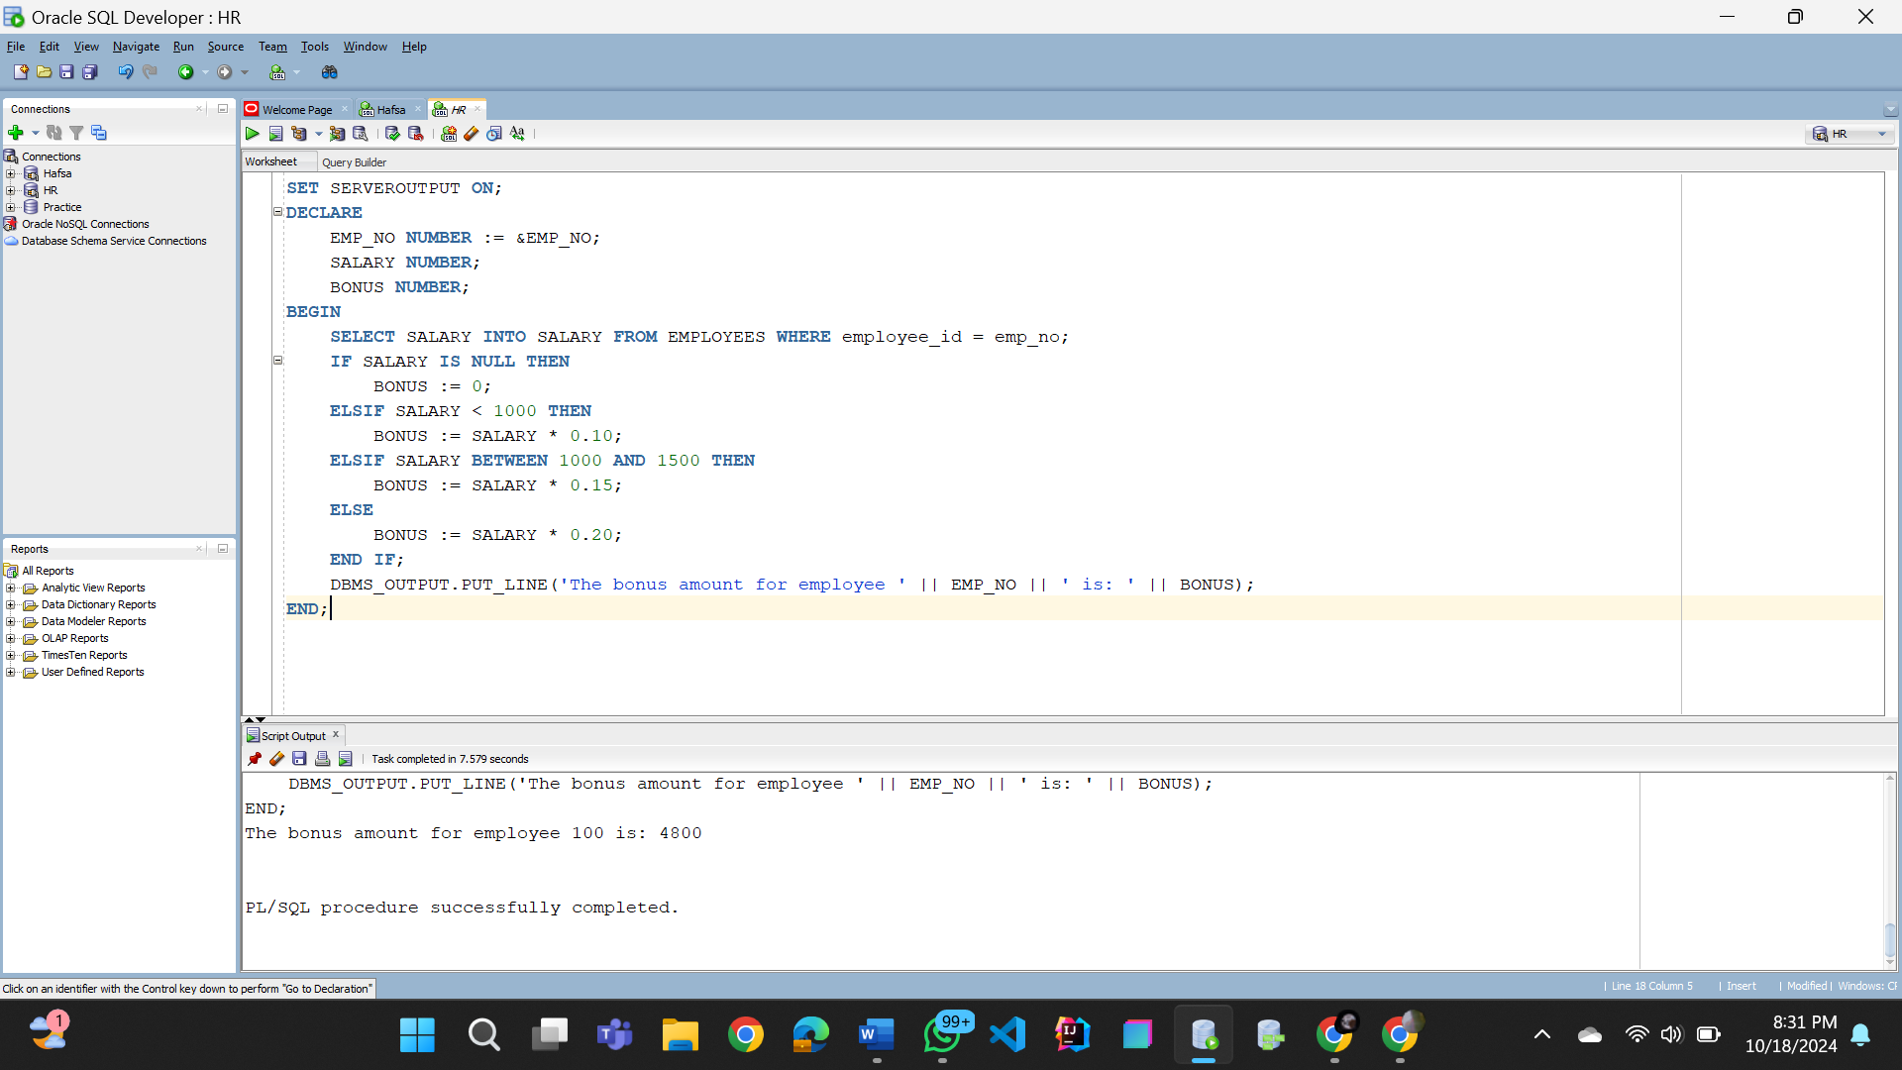

**Task no. 02**

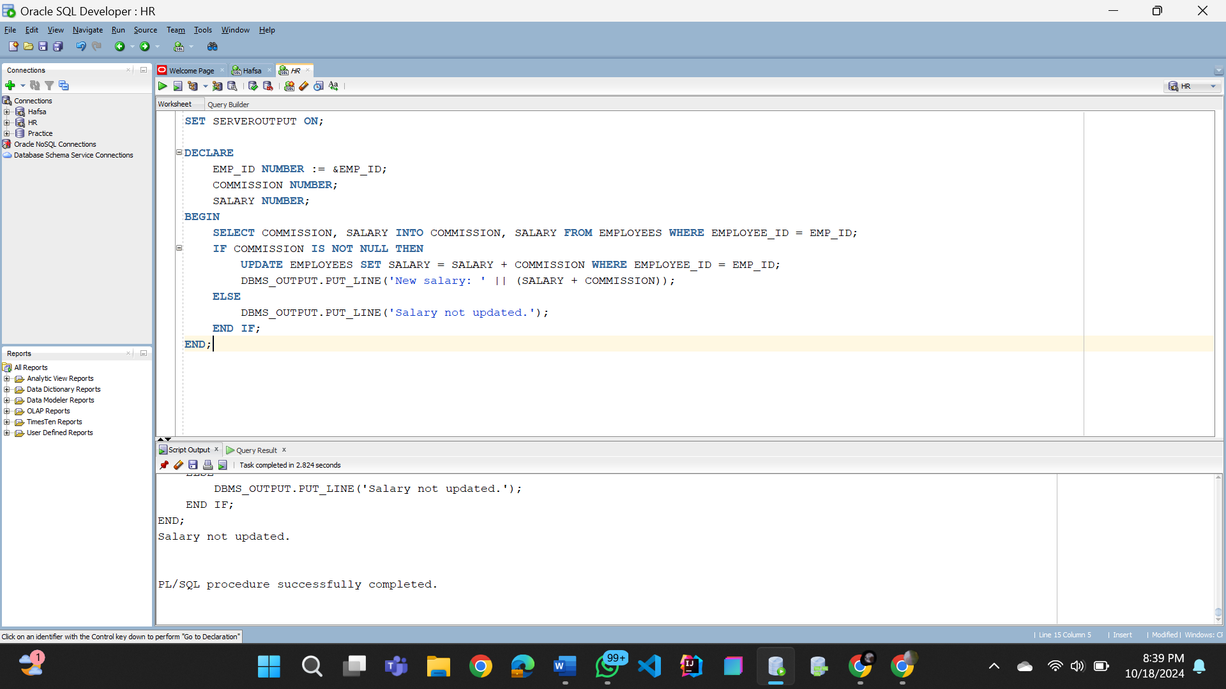

**Task no. 03**

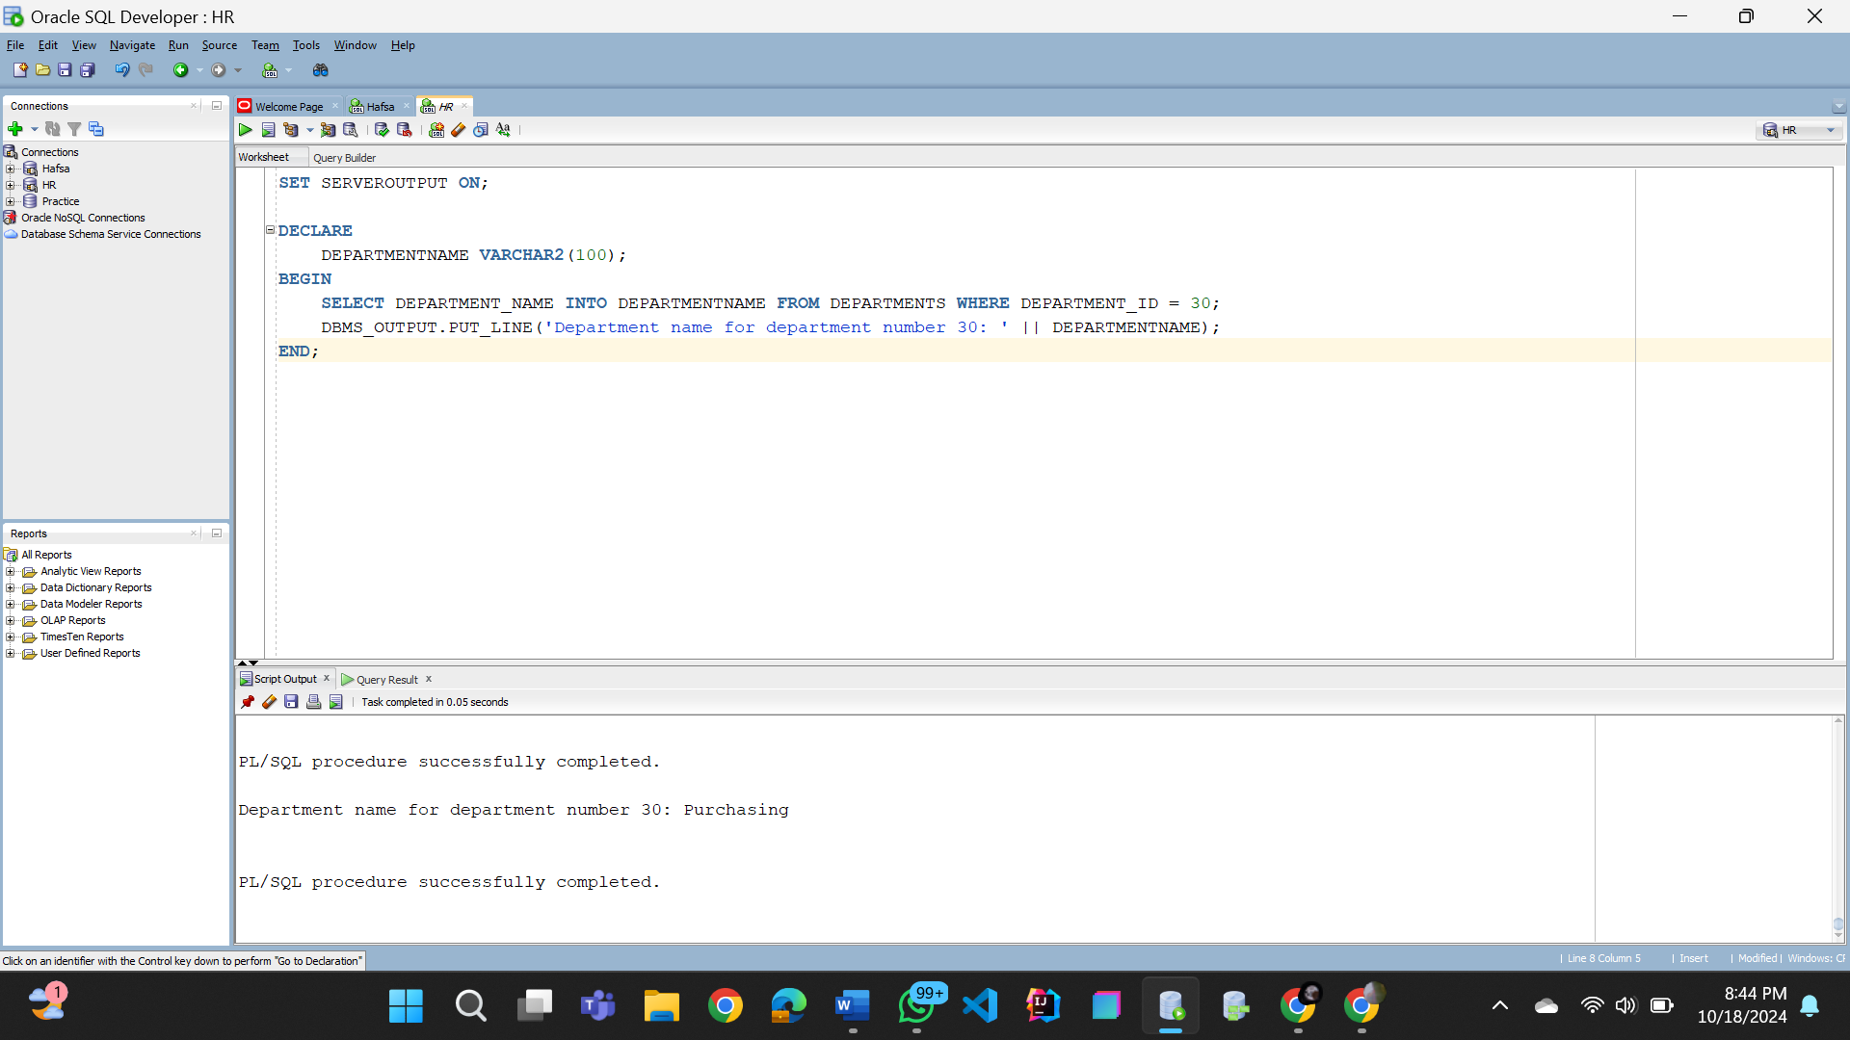

**Task no. 04**

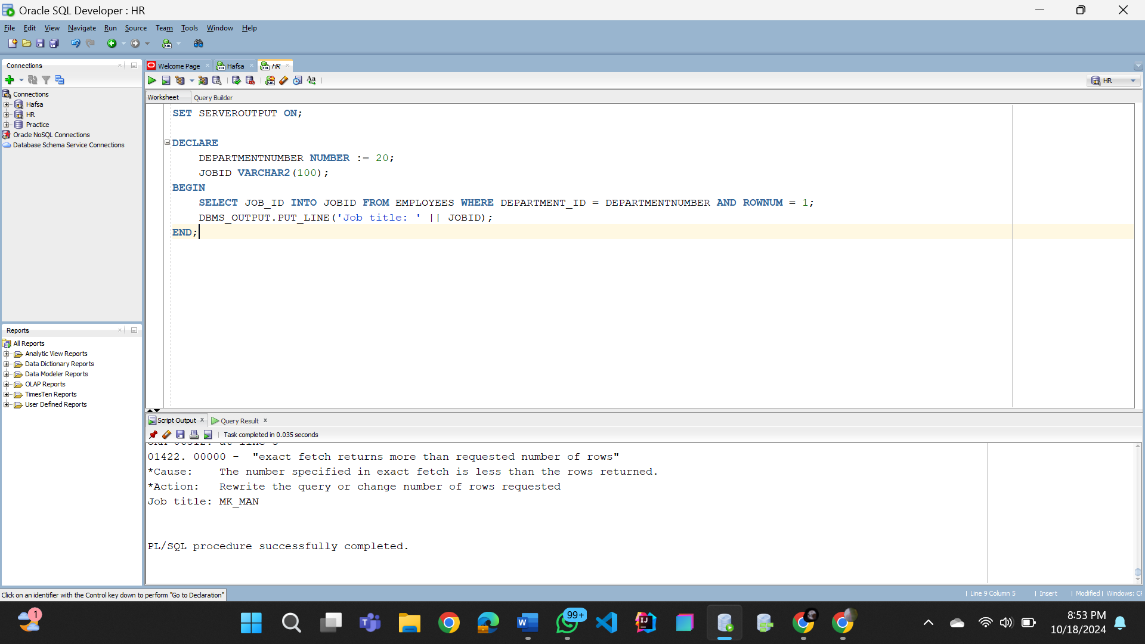

**Task no. 05**

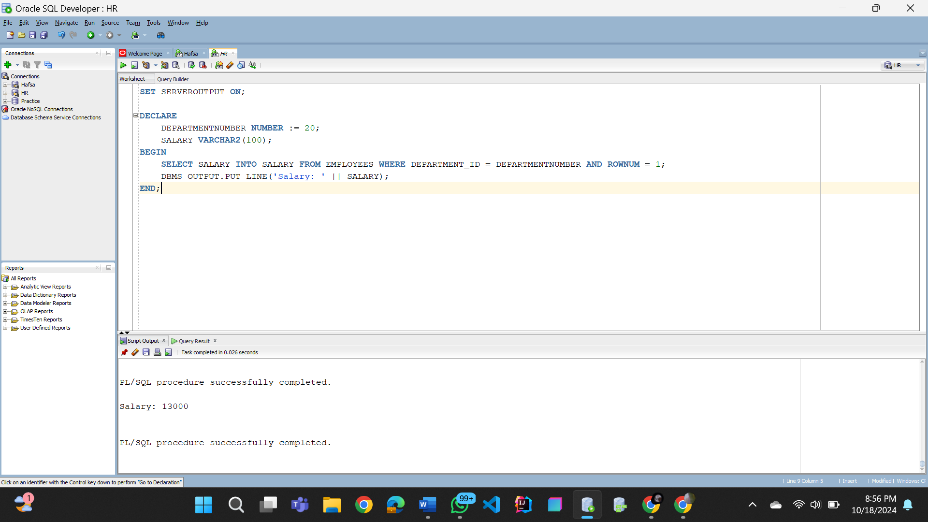

**Task no. 06**

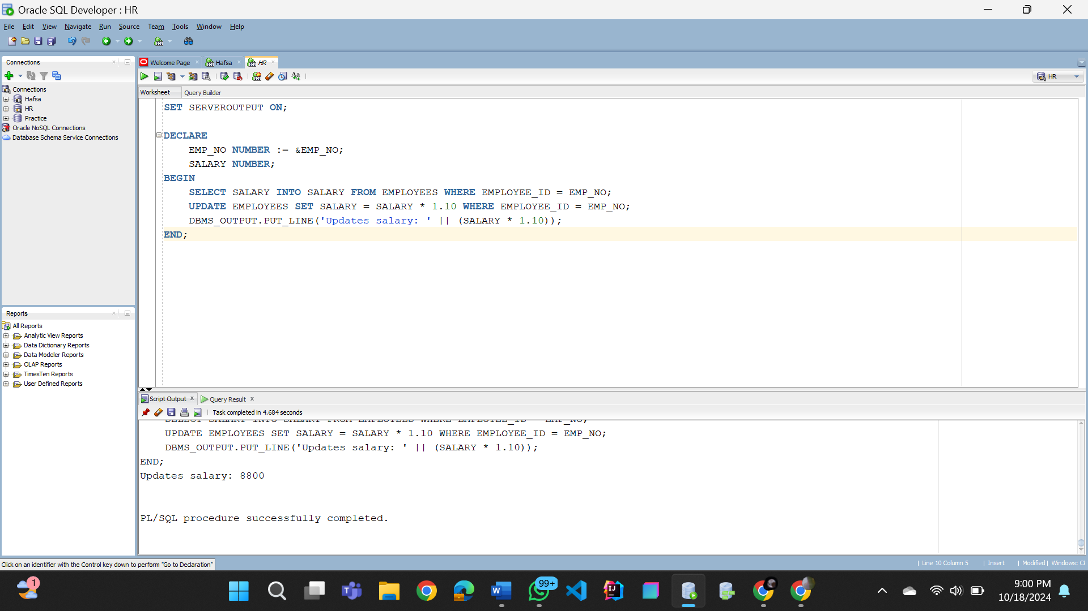

**Task no. 07**

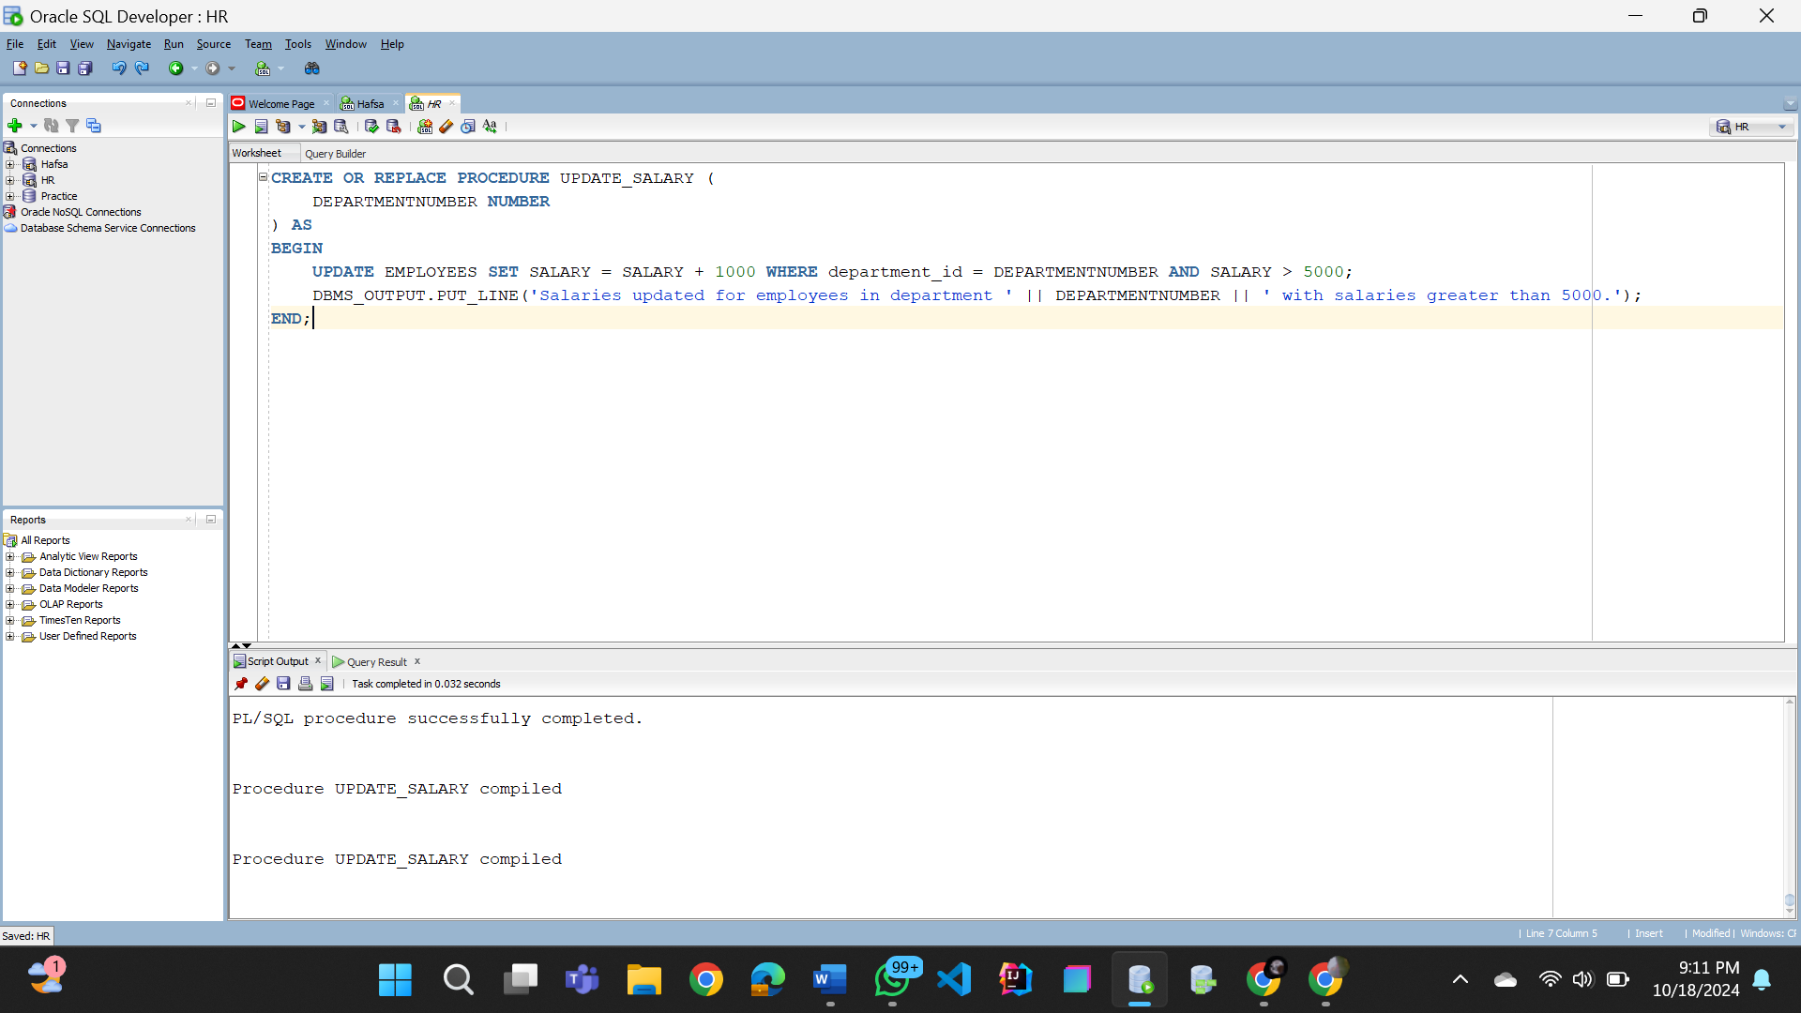

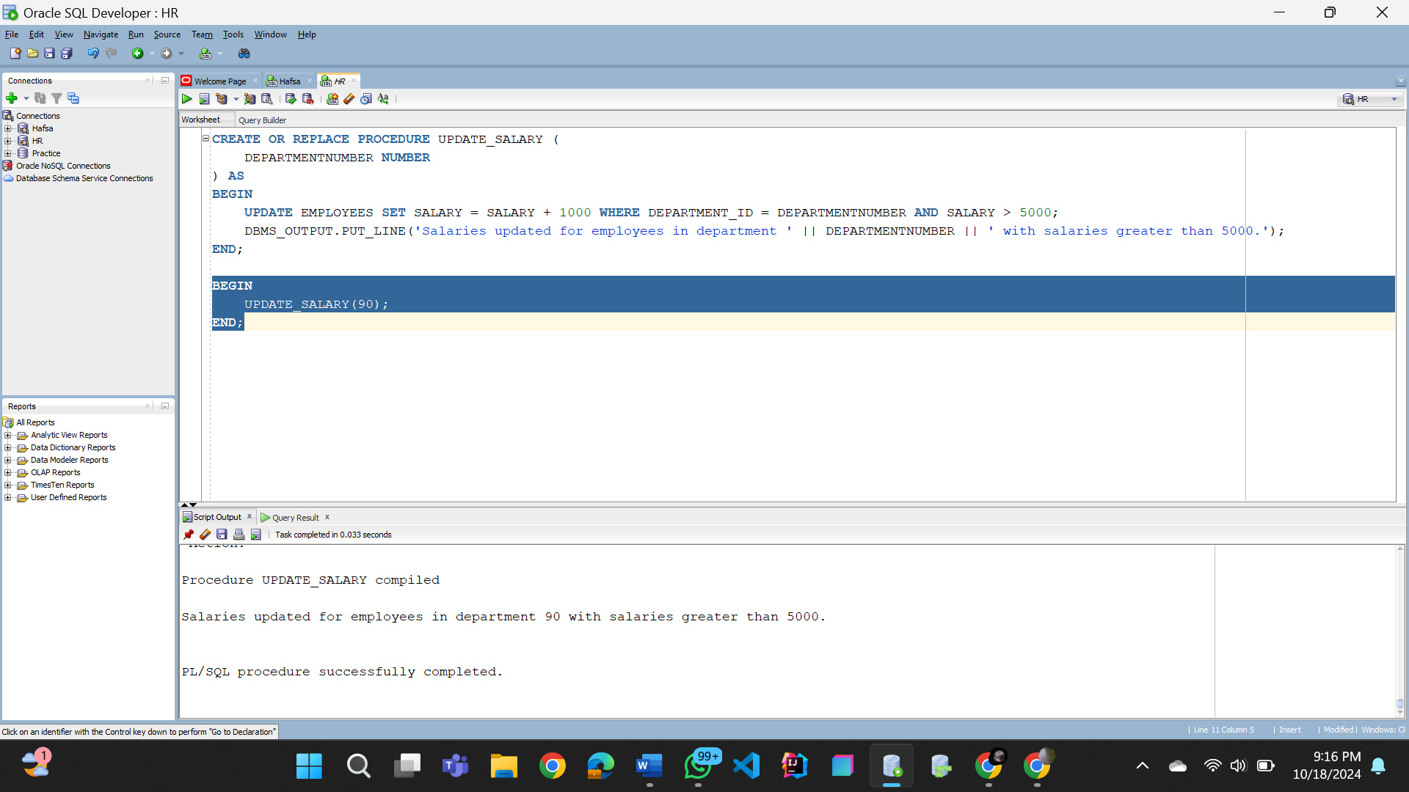

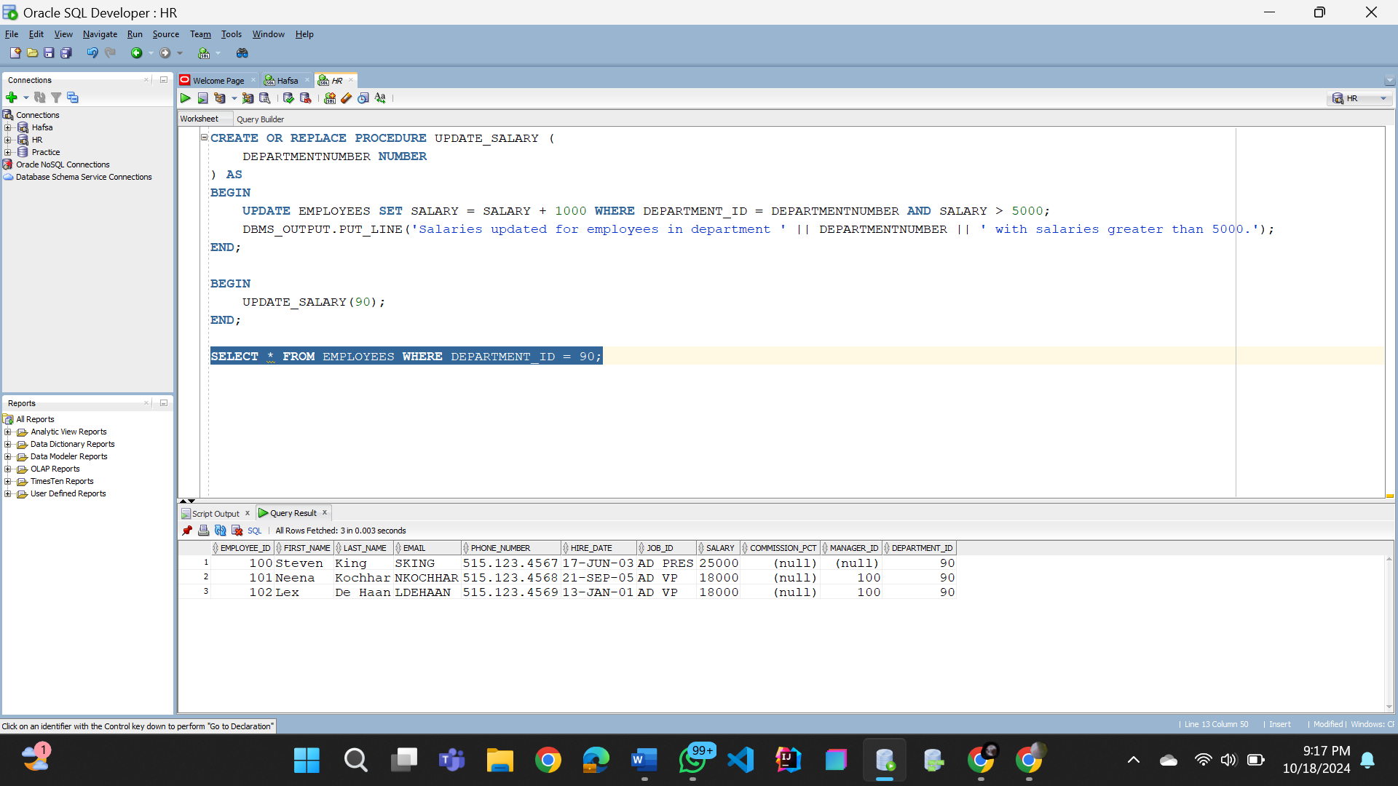

**Task no. 08 (A)**

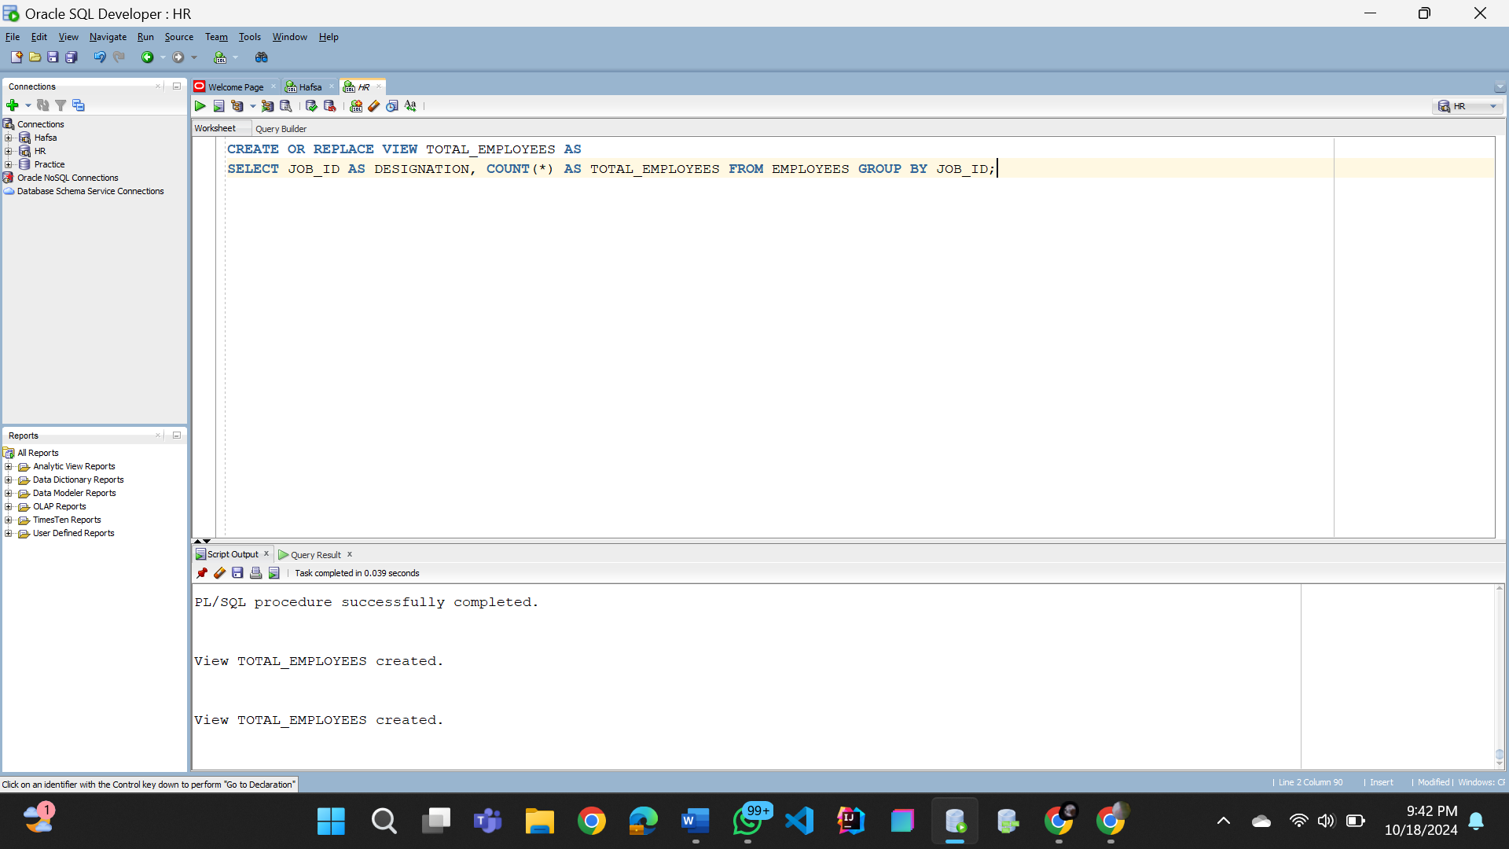

**Task no. 08 (B)**

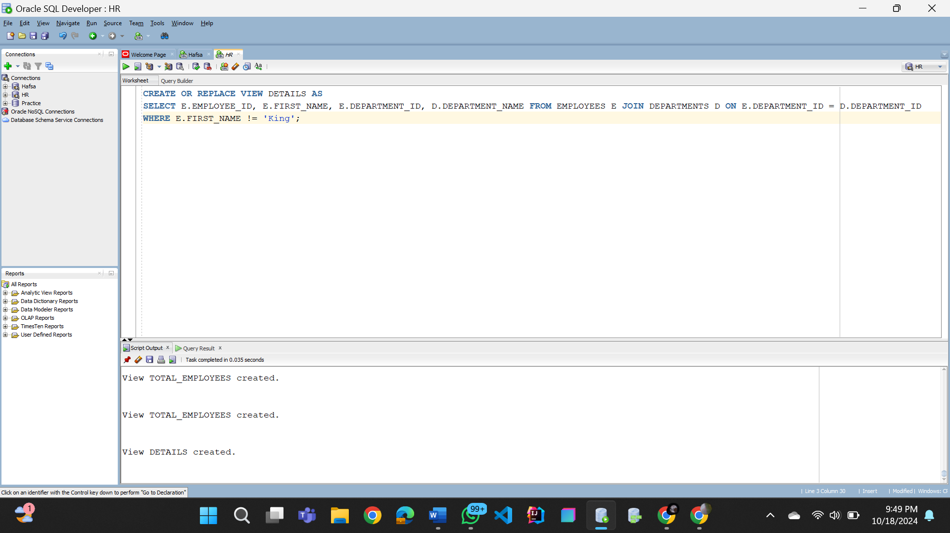

**Task no. 08 (C)**

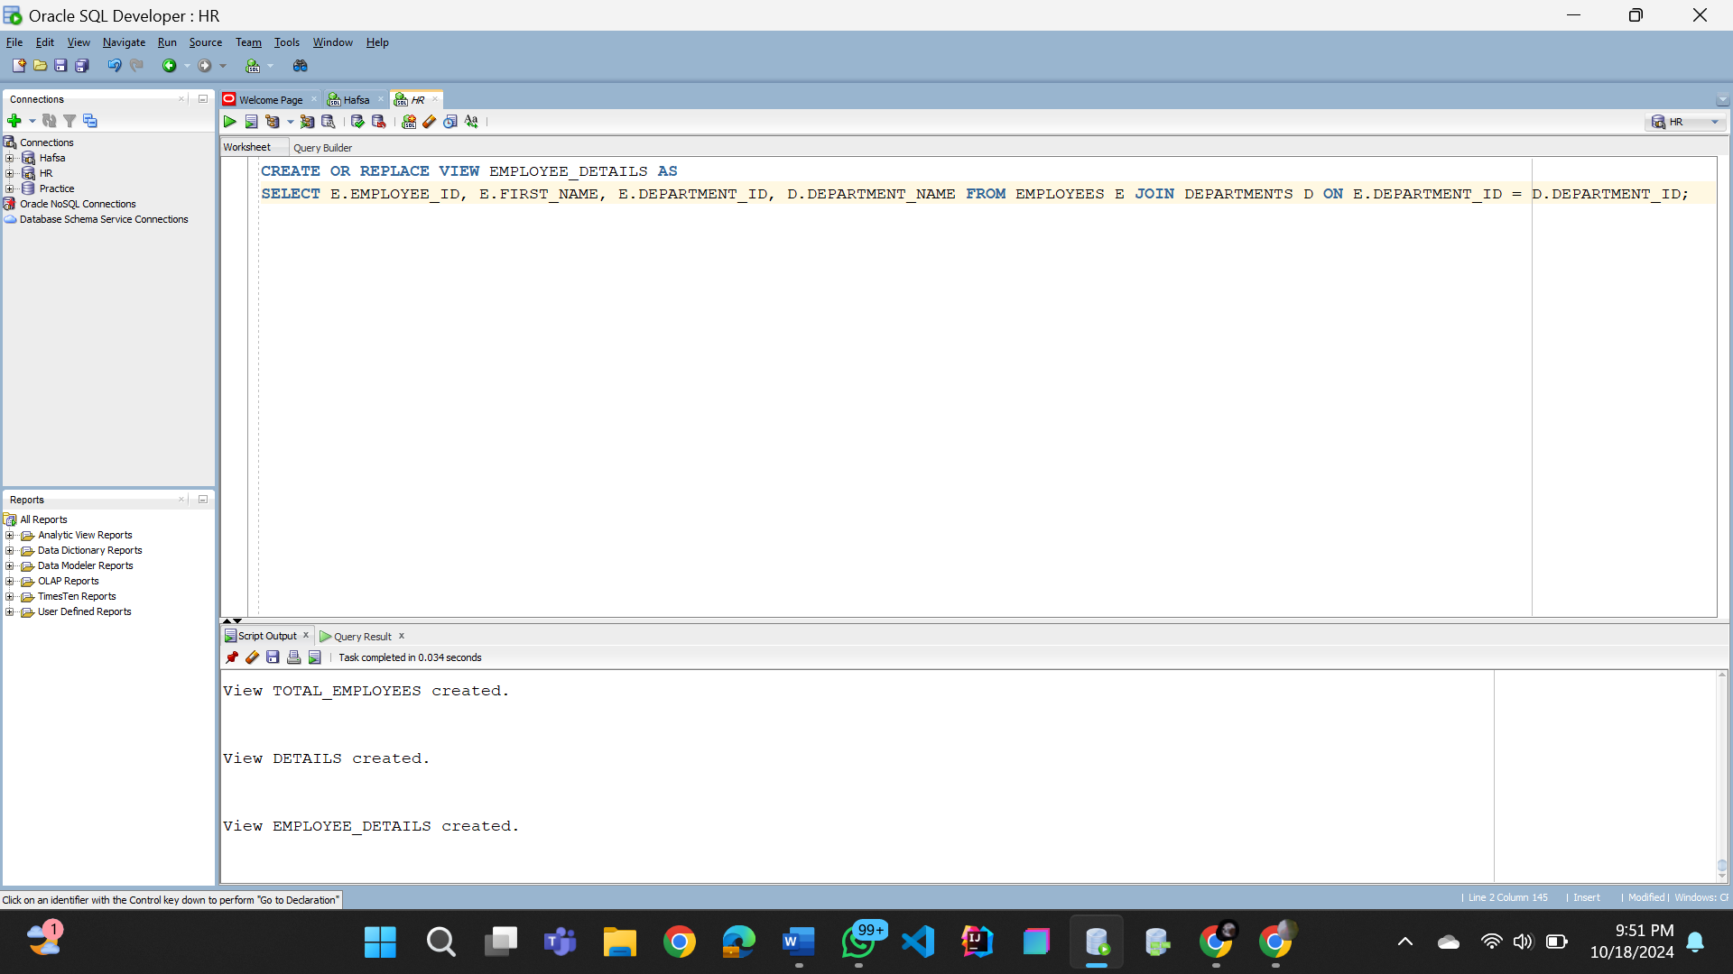

**Task no. 09**

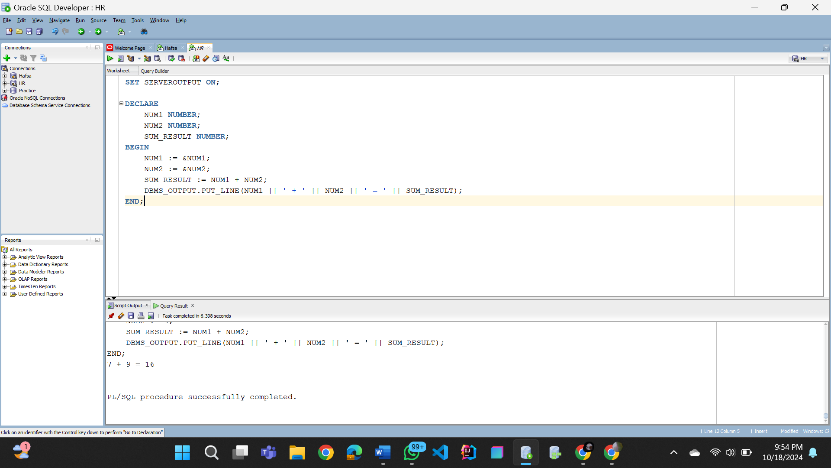

**Task no. 10**

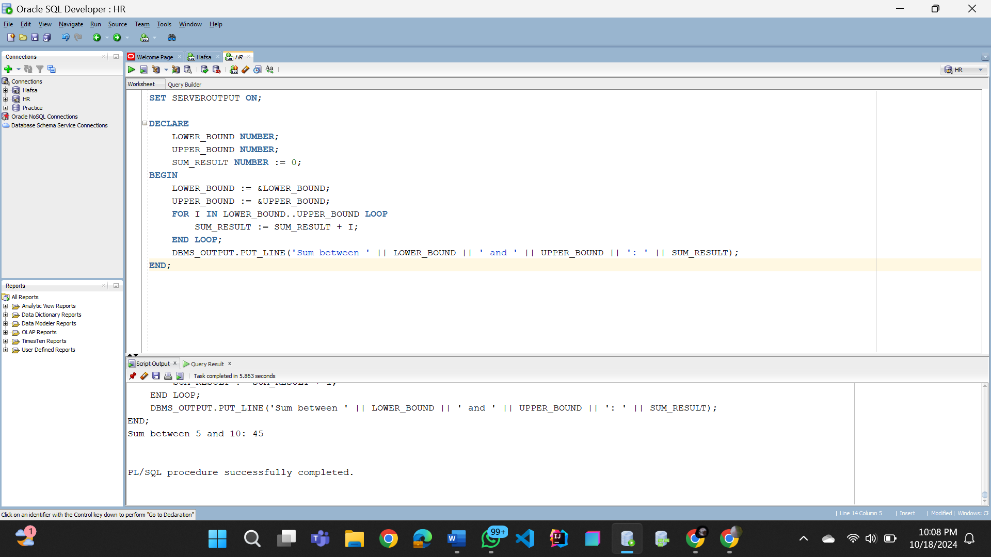

**Task no. 11**

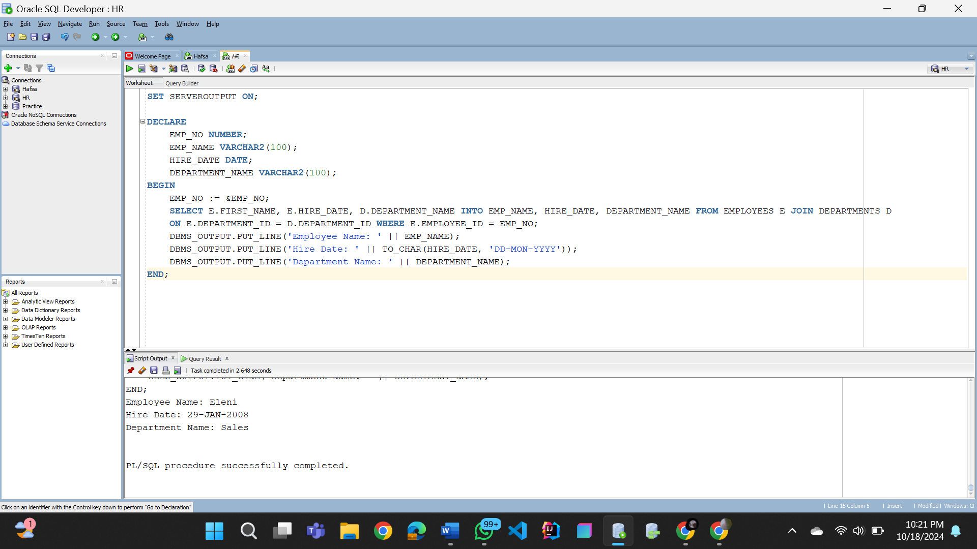

**Task no. 12**

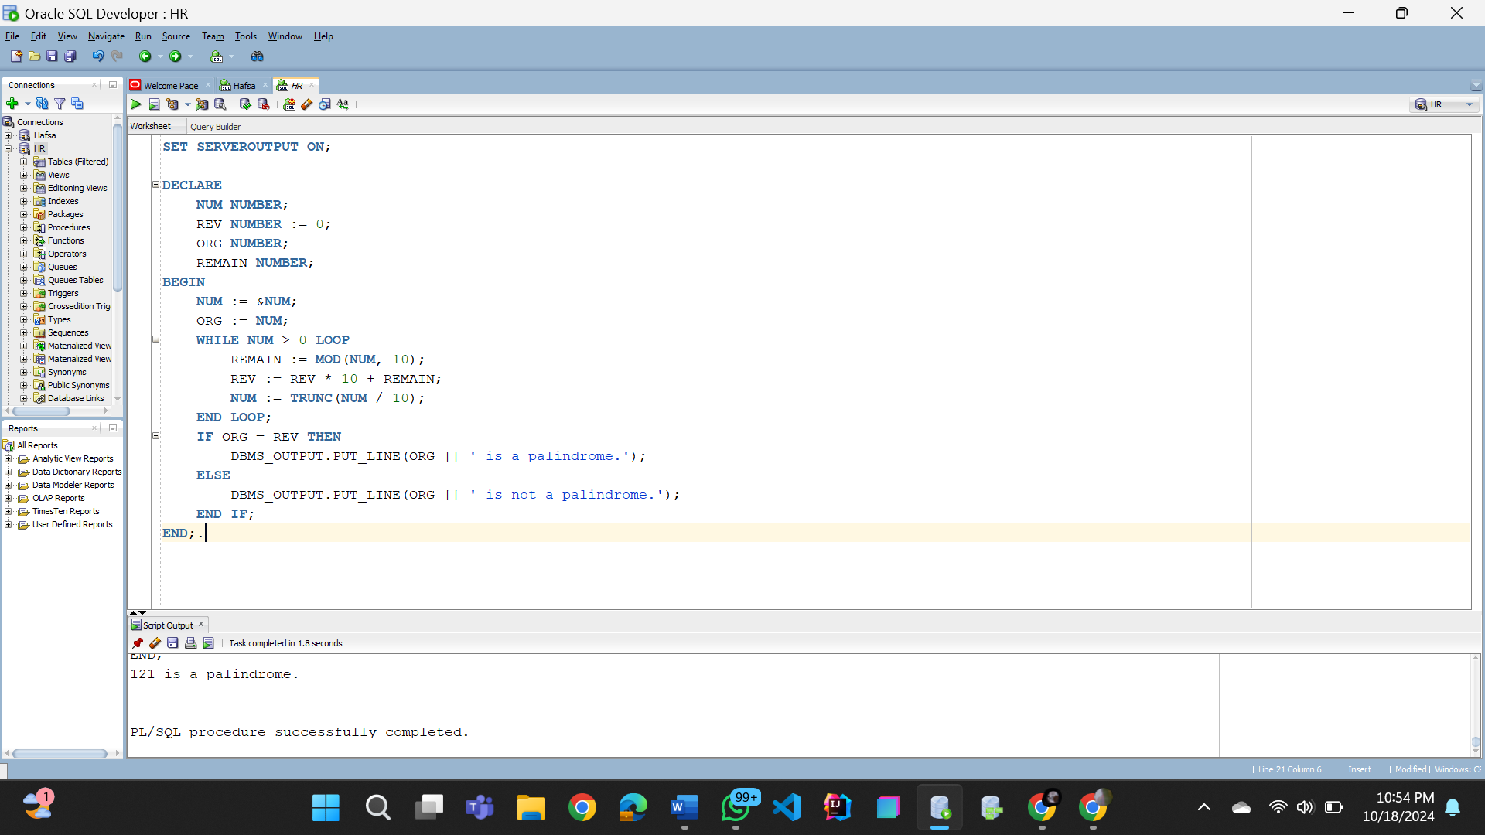

**Task no. 13**

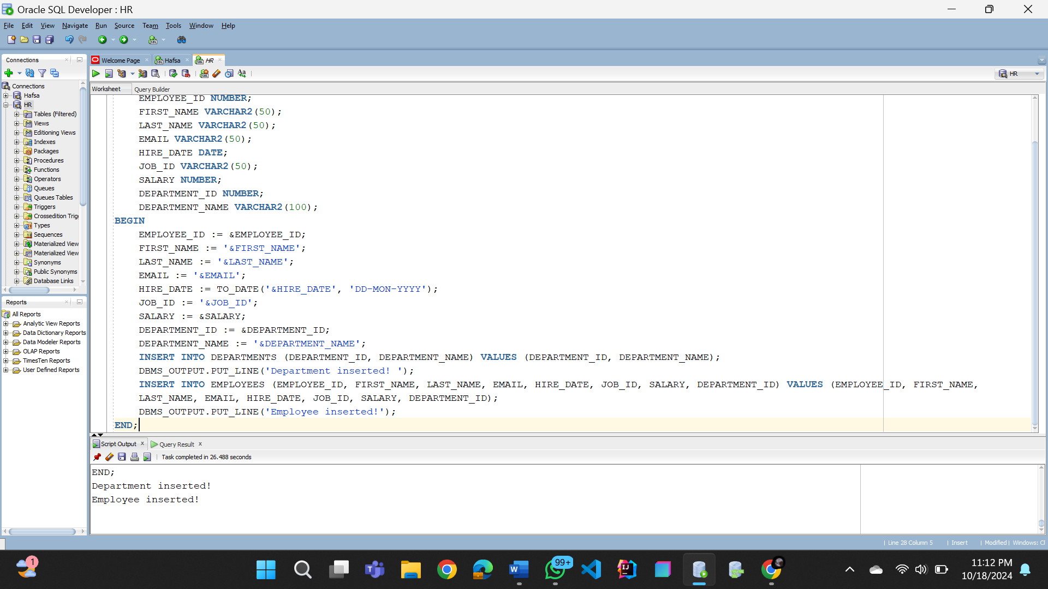

**Task no. 14**

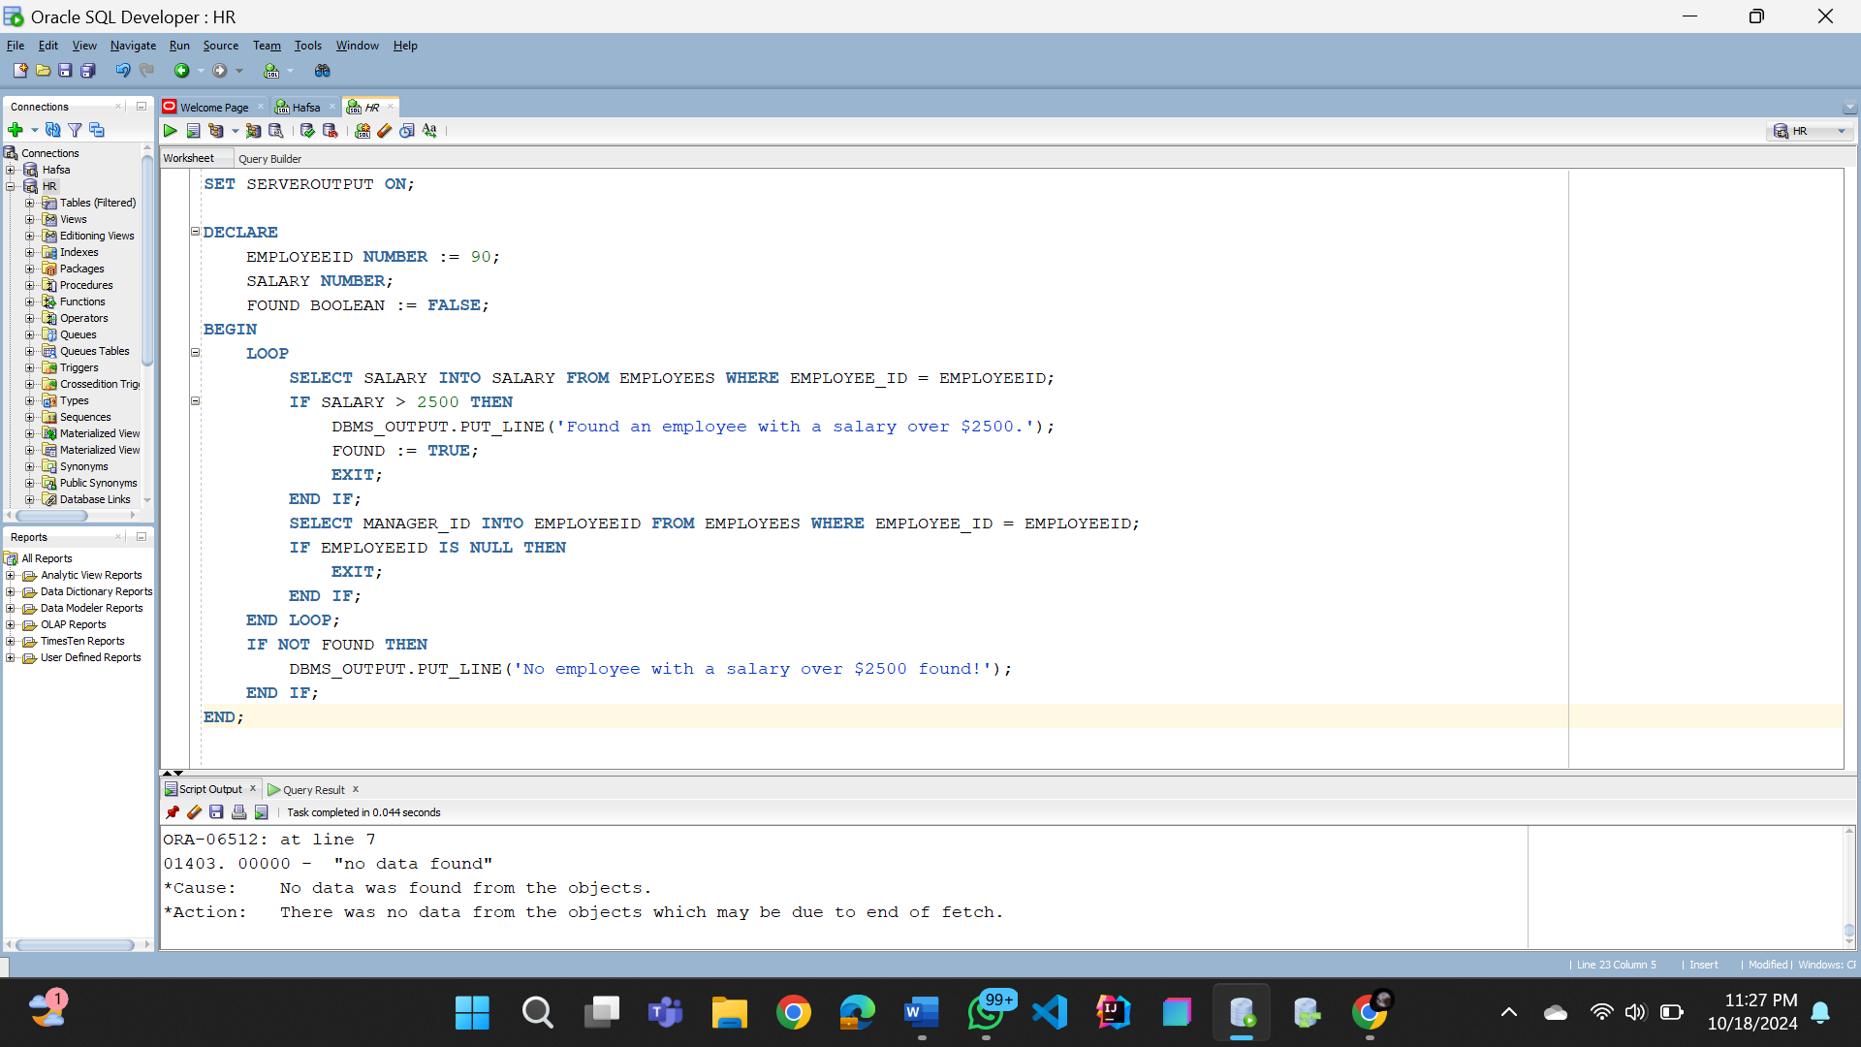

**Task no. 15**

